**DAILY ONLINE ACTIVITIES SUMMARY**

|  |  |  |  |  |
| --- | --- | --- | --- | --- |
| **Date:** | **24 June 2020** | **Name:** | **KHATHEEJA SAFREENA.** | |
| **Sem & Sec** | **4th sem, 2nd year** | **USN:** | **4al18cs037** | |
| **Online Test Summary** | | | | |
| **Subject** | **---------** | | | |
| **Max. Marks** | **----** | **Score** | **---** | |
| **Certification Course Summary** | | | | |
| **Course** | **INTRODUCTION TO R.** | | | |
| **Certificate Provider** | **GreatLearning** | **Duration** | | **5 hours.** |
| **Coding Challenges** | | | | |
| **Problem Statement: 1 program** | | | | |
| **Status: Executed** | | | | |
| **Uploaded the report in Github** | | **Yes** | | |
| **If yes Repository name** | | [http://shafreenasharief / lockdown-coding](http://shafreenasharief / lockdown-coding" \o "http://shafreenasharief / lockdown-coding)  [http://shafreenasharief / locked-down--certification-course](http://shafreenasharief / locked-down--certification-course" \o "http://shafreenasharief / locked-down--certification-course)  **[http://shafreenasharief / Daily\_Report](http://shafreenasharief / Daily_Report" \o "http://shafreenasharief / Daily_Report)** | | |
| **Uploaded the report in slack** | | **Yes** | | |

Certification Course Details: (Attach the snapshot and briefly write the report for the same)

Coding Challenges Details: (Attach the snapshot and briefly write the report for the same)

**CERTIFICATION COURSE SUMMARY:**

Today I started new course **INTRODUCTION TO INFORMATION R** through **GREAT LEARNING** the course is secluded for 6hrs. After the completion of course, certificate will be provided. I completed all the module .I attempted quiz ,which gave me a clear veiw about the topics that were thought and discussed.It consists of 7 modules which also include assessments.

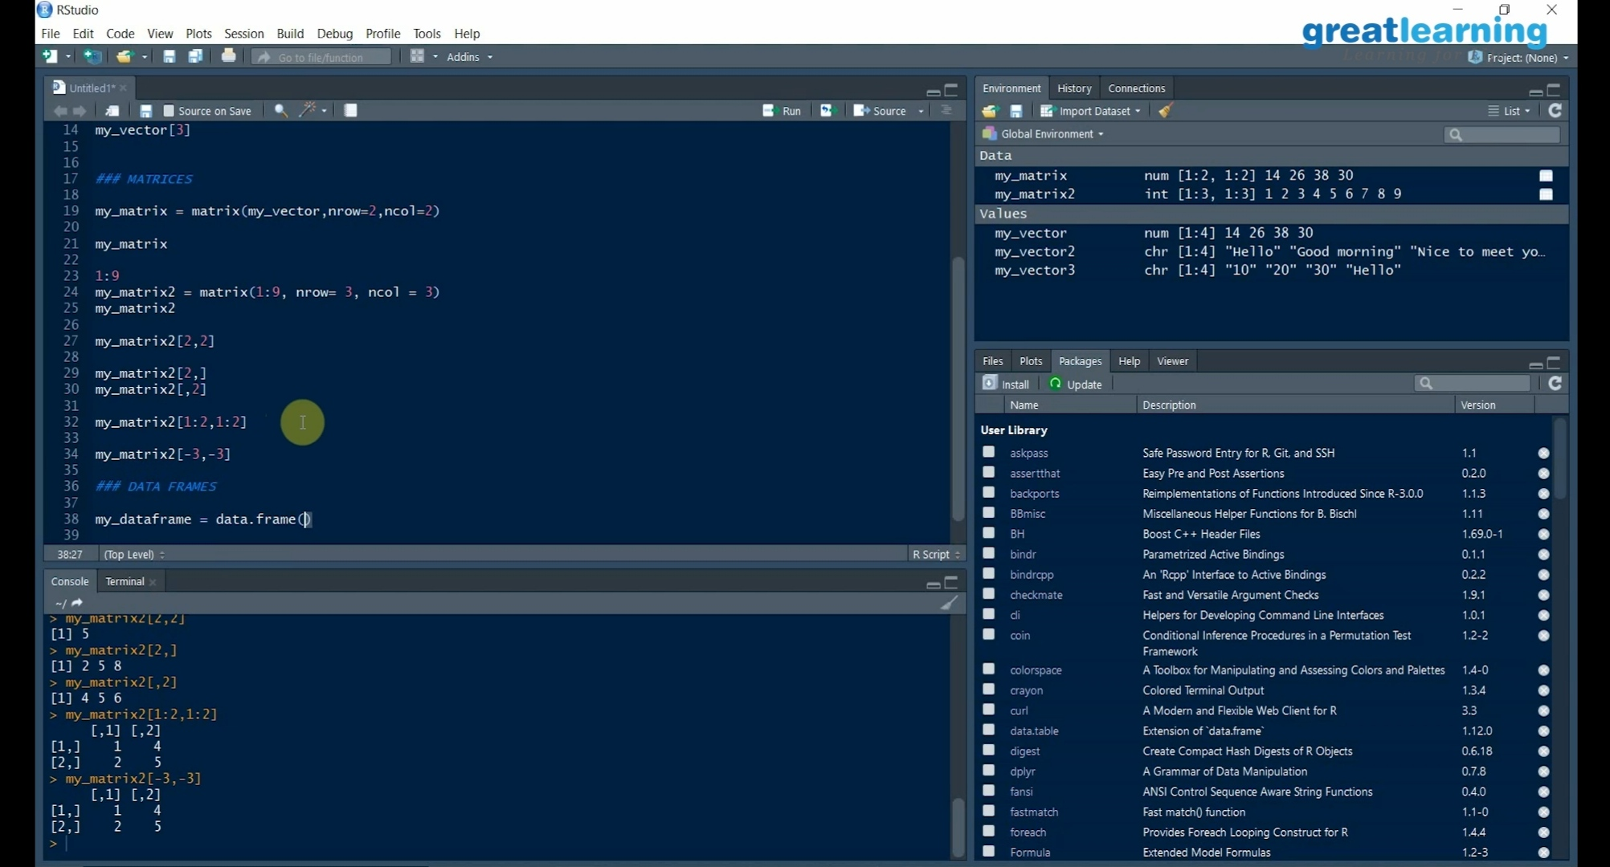

***CODING CHALLENGE :***

Today I solved 2 coding challenge,

One is given by college and another from geeksforgeeks.

1. **Write a C++ Program to Sort a stack using a temporary stack**

1)Create a temporary stack say tmpStack.

2)While input stack is NOT empty do this:  
• Pop an element from input stack call it temp  
• while temporary stack is NOT empty and top of temporary stack is greater than temp,  
pop from temporary stack and push it to the input stack  
• push temp in temporary stack

3)The sorted numbers are in tmpStack

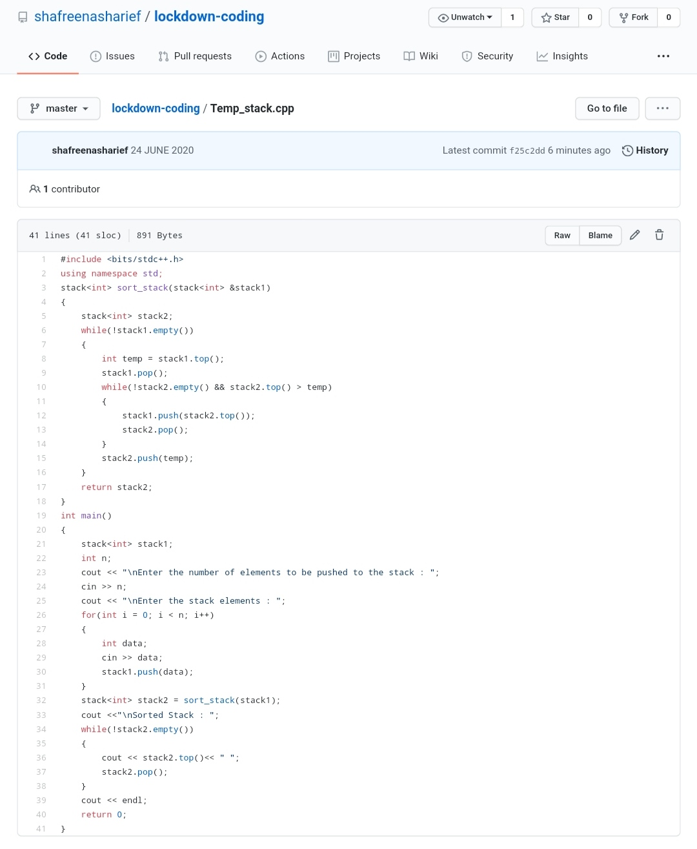

***EXTRA ACTIVITIES:***

Today I attended Online training on C, General talk Introduction, Data types, Input and Outputs, Operators Quiz which is from 2:30-4:00 pm.

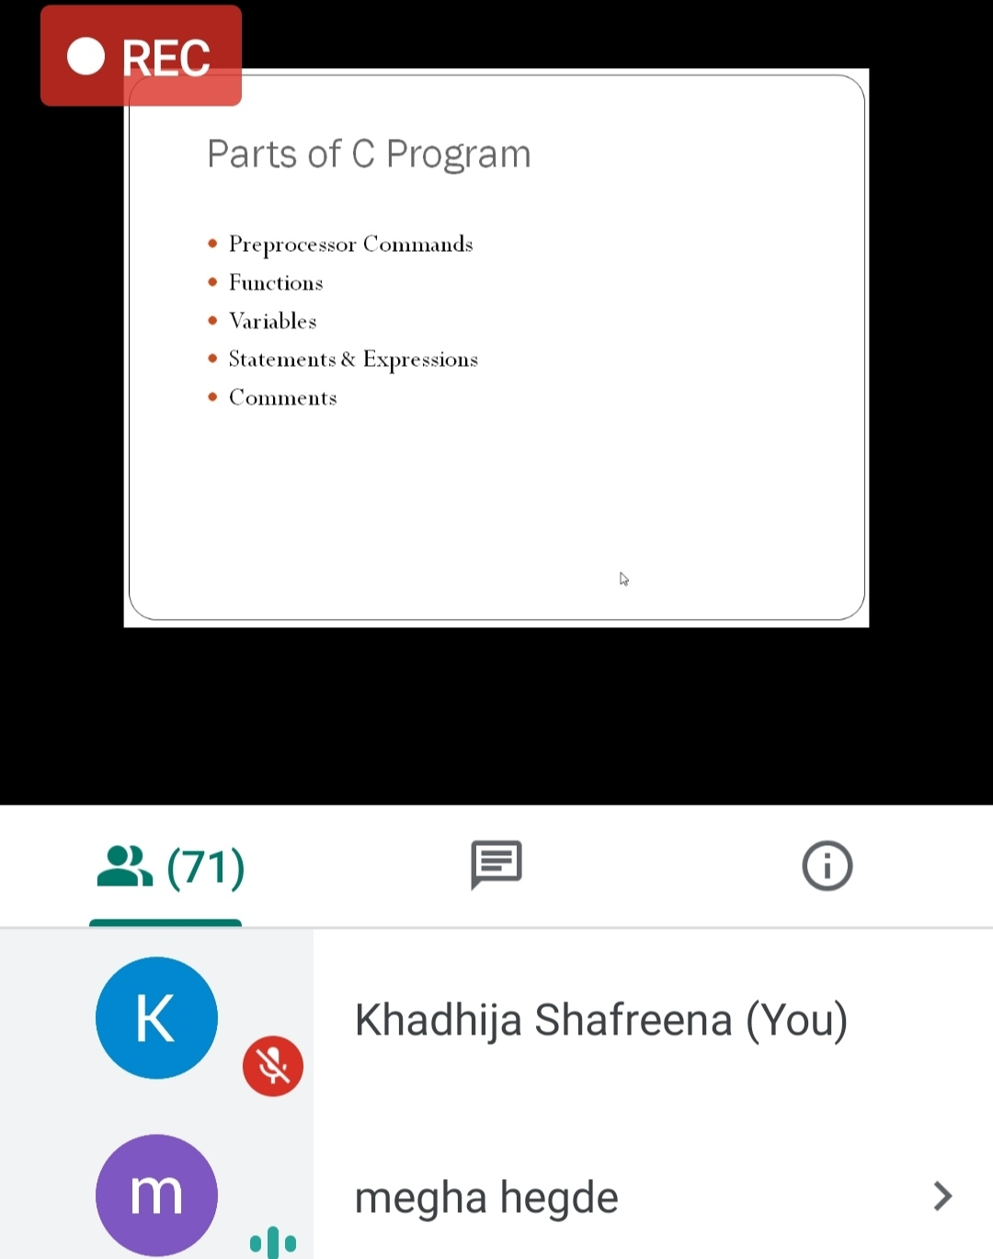

**ONLINE TEST OF C:**

After attending the class, I attended quiz for 15 marks and scored 7.

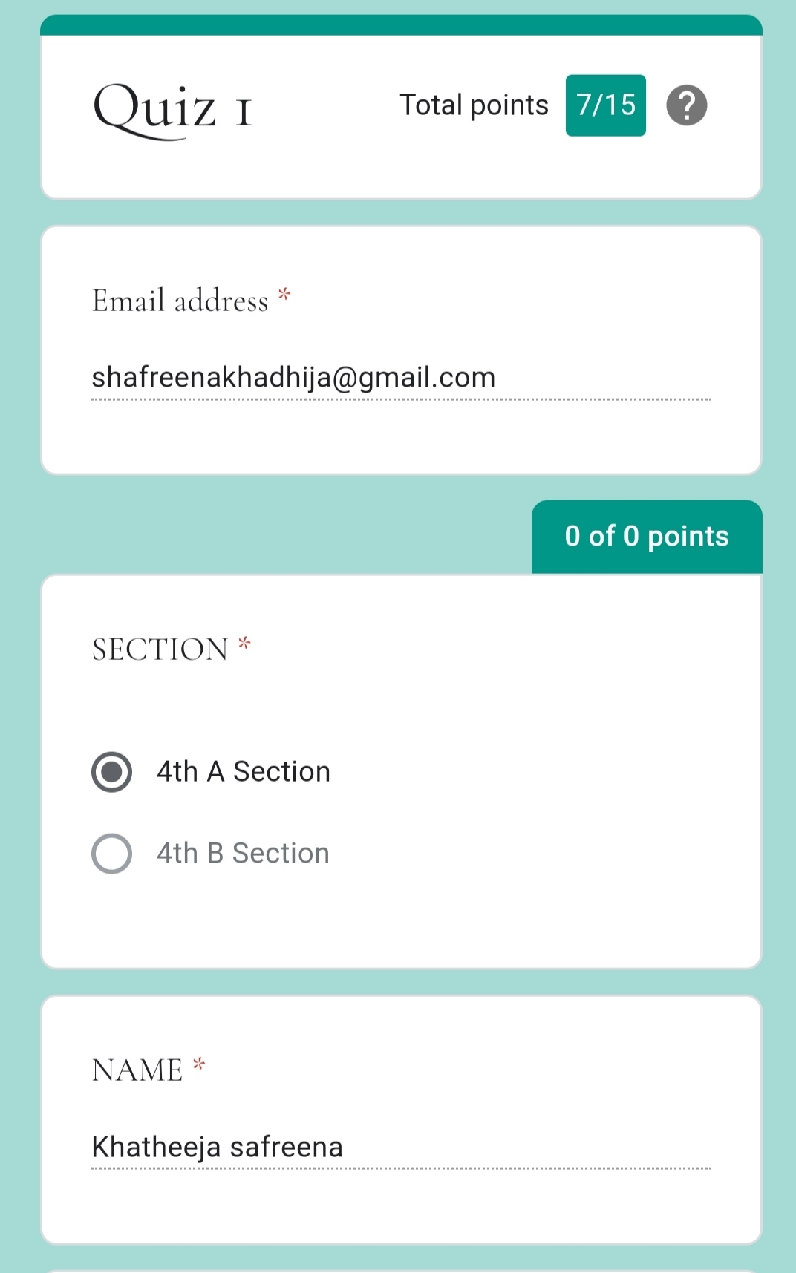

**SOLUTION** : I have uploaded the solution of the above 3 coding problems in my GitHub repository

[http://shafreenasharief / lockdown-coding](http://shafreenasharief / lockdown-coding" \o "http://shafreenasharief / lockdown-coding)

[http://shafreenasharief / locked-down--certification-course](http://shafreenasharief / locked-down--certification-course" \o "http://shafreenasharief / locked-down--certification-course)

[http://shafreenasharief / Daily\_Report](http://shafreenasharief / Daily_Report" \o "http://shafreenasharief / Daily_Report)